Model- Sycamore seed

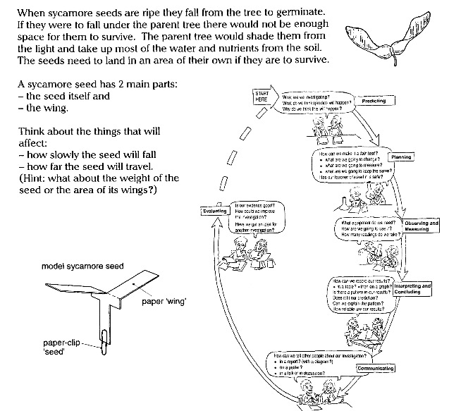

Plan an investigation to find out what affects the length of time it takes a model sycamore seed to fall. You could make a model out of card, like the one given in the diagram above. You could alter the weight by adding paper-clips.

Credits- Spotlight science 7

MYP 3 Science Assessment Criteria for Lab report

Level | Criteria B- Inquiring and designing | Task specific indicators
0 | The student does not reach a standard described by any of the descriptors below. | The student does not reach a standard described by any of the descriptors below.
1-2 | The student is able to:  i. state a problem or question to be tested by a scientific investigation, with limited success  ii. state a testable hypothesis  iii. state the variables  iv. design a method, with limited success. | Research question is present.  Attempt to list variables and control.  Data is limited and not always in line with the research question.
3-4 | The student is able to:  i. state a problem or question to be tested by a scientific investigation  ii. outline a testable hypothesis using scientific reasoning  iii. outline how to manipulate the variables, and state how relevant data will be collected  iv. design a safe method in which he or she selects materials and equipment. | Research question is adequately formulated.  Attempt to identify relevant variables and control.  Data is relevant and in line with the research question.
5-6 | The student is able to:  i. outline a problem or question to be tested by a scientific investigation  ii. outline and explain a testable hypothesis using scientific reasoning  iii. outline how to manipulate the variables, and outline how sufficient, relevant data will be collected  iv. design a complete and safe method in which he or she selects appropriate materials and equipment. | Clear research question is formulated.  Variables and controls identified are relevant  Uses methods to collect and record. appropriate information in line with the research question.
7-8 | The student is able to:  i. describe a problem or question to be tested by a scientific investigation  ii. outline and explain a testable hypothesis using correct scientific reasoning  iii. describe how to manipulate the variables, and describe how sufficient, relevant data will be collected  iv. design a logical, complete and safe method in which he or she selects appropriate materials and equipment. | Formulates a clear and focused research question.  Variables and controls are accurately identified.  Uses methods accurately to collect and record appropriate and varied information in line with the research question.

MYP 3 Science Assessment Criteria for lab report
Level | Criteria C- Processing and evaluating | Task specific indicators
0 | The student does not reach a standard described by any of the descriptors below. | The student does not reach a standard described by any of the descriptors below.
1-2 | The student is able to:  i. collect and present data in numerical and/or visual forms  ii. accurately interpret data  iii. state the validity of a hypothesis with limited reference to a scientific investigation  iv. state the validity of the method with limited reference to a scientific investigation  v. state limited improvements or extensions to the method. | With guidance, the student attempts to collect and record some data in a table.  With guidance, the student organizes and presents data using simple mathematical calculation and tables.  With guidance, the student attempts to identify a trend, pattern or relationship in the data.  With guidance, the student attempts to draw a conclusion but it is not consistent with the interpretation of the data.  There is no discussion of errors.
3-4 | The student is able to:  i. correctly collect and present data in numerical and/or visual forms  ii. accurately interpret data and describe results  iii. state the validity of a hypothesis based on the outcome of a scientific investigation  iv. state the validity of the method based on the outcome of a scientific investigation  v. state improvements or extensions to the method that would benefit the scientific investigation. | With guidance, the student collects and records relevant data in a suitable format.  With guidance, the student organizes and presents data using numerical and visual forms (bar graphs) with some errors.  With guidance, the student identifies a trend, pattern or relationship in the data.  With guidance, the student draws a conclusion partially consistent with the interpretation of the data.  Experimental errors are mentioned.
5-6 | The student is able to:  i. correctly collect, organize and present data in numerical and/or visual forms  ii. accurately interpret data and describe results using scientific reasoning  iii. outline the validity of a hypothesis based on the outcome of a scientific investigation  iv. outline the validity of the method based on the outcome of a scientific investigation  v. outline improvements or extensions to the method that would benefit the scientific investigation. | With guidance, the student collects and records relevant data in a table using units of measurement.  With guidance, the student often organizes, transforms and presents data in numerical forms (mathematical calculation) and visual forms (bar graphs) correctly most of the time.  With guidance, the student often states a trend, pattern or relationship shown in the data.  With guidance, the student often draws a conclusion based on the interpretation of the data by applying scientific reasoning.  Experimental errors and their possible effects are often discussed.
7-8 | The student is able to:  i. correctly collect, organize, transform and present data in numerical and/ or visual forms  ii. accurately interpret data and describe results using correct scientific reasoning  iii. discuss the validity of a hypothesis based on the outcome of a scientific investigation  iv. discuss the validity of the method based on the outcome of a scientific investigation  v. describe improvements or extensions to the method that would benefit the scientific investigation. | With guidance, the student collects and records accurate data in a table with units of measurement.  With guidance, the student organizes, transforms and presents data in numerical forms (mathematical calculation) and visual forms (bar graphs) correctly.  With guidance, the student states a trend, pattern or relationship shown in the data.  With guidance, the student draws a clear conclusion based on the interpretation of the data by applying scientific reasoning.  Experimental errors and their possible effects are discussed.

